# APA Charts and Tables Quick Guide

Tables:

* Must have top and bottom borders for the first row
* Must have bottom border for the last row
* First column usually right aligned, second+ usually centered
* First column usually X variables, other columns statistics (M, SD, t, d, etc.)
* 2 decimal places

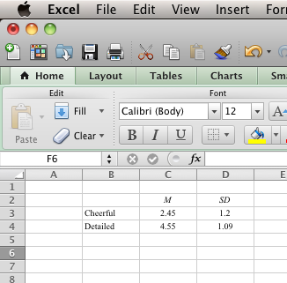Table 1

*Table Title In Italics*

|  |  |  |
| --- | --- | --- |
|  | *M* | *SD* |
| Cheerful | 2.45 | 1.20 |
| Detailed | 4.55 | 1.09 |

To create:

Use excel – it’s easier.

Type in the information.

Use the borders button to create the correct border combinations.

Right click on cell > format cell > change to number

> Two decimal places

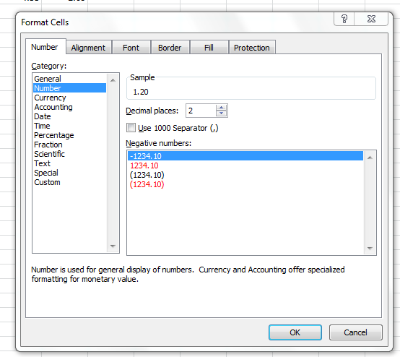

Bar Graphs:

* Must have x and y axis labels.
* Must have bar labels (what are the groups, bars, etc.)
* Must have an accurate y-axis (i.e. doesn’t go higher/lower than actual scale) – see below on line graphs for the how to.
* Error bars

To create:

* Type in the information in excel.
* 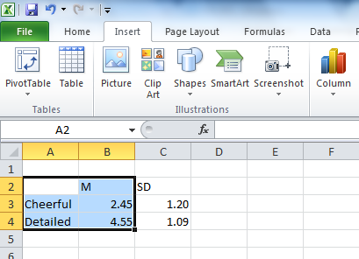Highlight JUST the names and means (you will use the SDs later)
* Click insert > column > 2D column.
* Delete any extra labels or legends you don’t need.
* To get x and y axis > make sure you are clicked on the chart (or you won’t see the options).
* Go to chart tools > layout > axis titles.
* 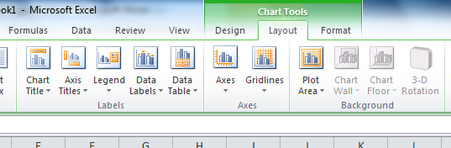
* 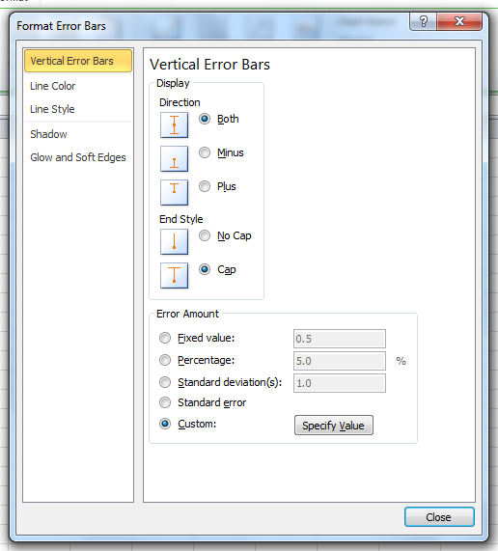Add the axis titles!
* When you highlight the chart labels you will automatically get the bars “labels”. ** you can also do this separately for charts with number labels – please ask.
* Error bars > chart tools > layout > error bars > more error bar options.
* Click custom > specify value
* 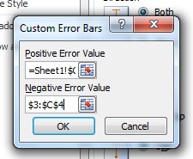
* Highlight the SD values (just the numbers) for BOTH the positive and negative error bars.
* 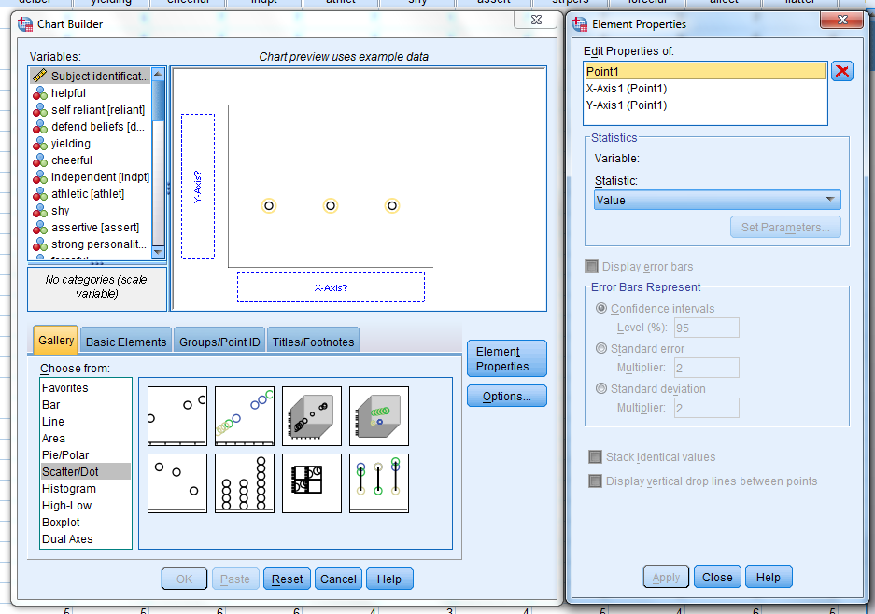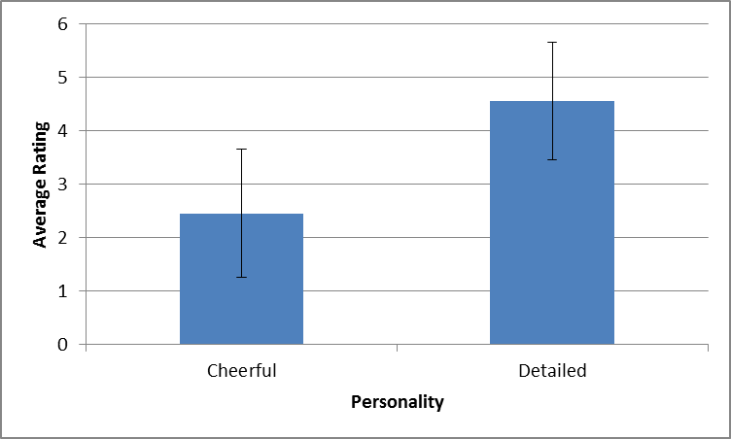

Scatter Plots (easier in SPSS)

* Graphs > chart builder > ok (if you get this error message)
* Click scatter dot (bottom left) > pick the first one
* Drag your variables into the x and y axis
* 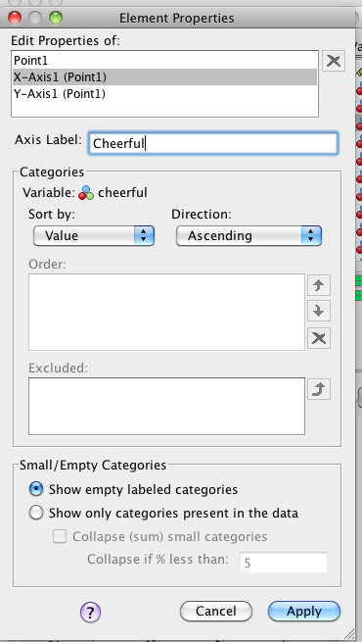In the right hand menu, you can select the x and y axis individually to label them properly (i.e. not the variable name.

Be sure to hit apply at the bottom of the chart.

Hit OK to make the chart – this will pull up SPSS output.

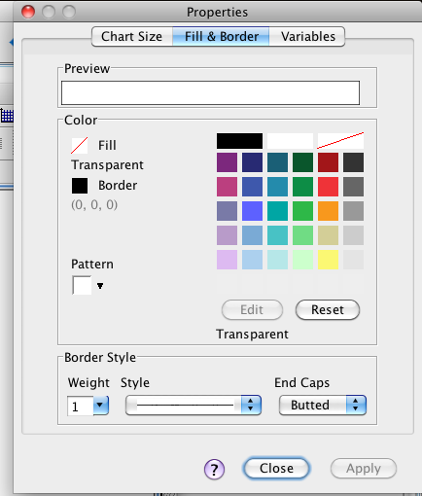Double click on the chart TWICE. You will get the background edit window.

Change the background to the transparent fill (white with the red line through it).

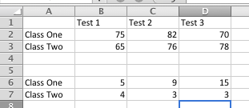Line Graphs:

* Usually for continuous data.
* Must have the legend (if more than one line).
* Must have x and y axis labels.
* Must have Time point labels (on x-axis).
* Error bars!
* Y-axis should include all the values of your scale.

To create:

* Type in all your data in Excel (you will have more than one row) – above I have the scores and the SDs in the second set of data.
* Highlight all of the data to graph, including group names and time labels…then excel will do it for you.
* Insert > charts > line.
* Insert x and y axis labels > must be clicked on chart > layout > axis titles (same as above).
* Error bars > must be clicked on chart > layout > error bars.
* Custom error bars (same as above). You will get a box asking which series (pick the first one).
* Specify value > highlight the SD ROW (since we picked only class one) for both the positive and negative.
* You will hit OK, then do the steps over again for the second series (line). If you click on the second line before you hit layout error bars it will help.
* Right click on the y-axis > format axis.
* Change the minimum and maximum values as necessary for your scale.

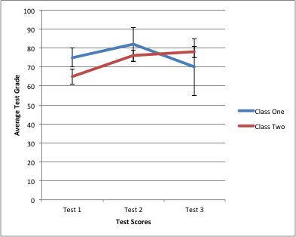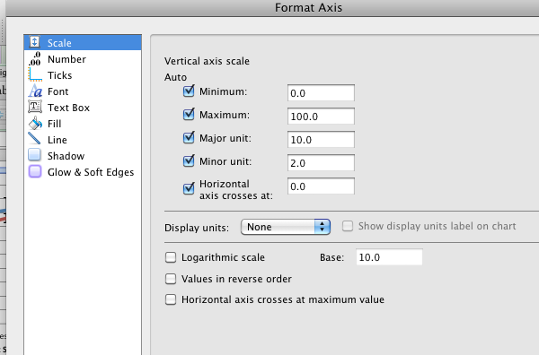

* You can also change fonts and sizes – just click on the piece you want to change (axis title, axis, legend).
* Click on Home tab.
* Just change the font from those options. Be sure to hit enter.